**Exercise 1: Setting up Junit**

**Implementation:**

**PROJECT STRUCTURE:**

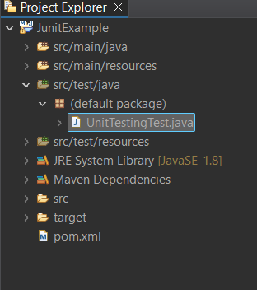

**CODE:**

**pom.xml:**

<project xmlns="http://maven.apache.org/POM/4.0.0" xmlns:xsi="http://www.w3.org/2001/XMLSchema-instance" xsi:schemaLocation="http://maven.apache.org/POM/4.0.0 https://maven.apache.org/xsd/maven-4.0.0.xsd">

<modelVersion>4.0.0</modelVersion>

<groupId>myProject</groupId>

<artifactId>JunitExample</artifactId>

<version>0.0.1-SNAPSHOT</version>

<dependencies>

<!-- junit 5, unit test -->

<dependency>

<groupId>org.junit.jupiter</groupId>

<artifactId>junit-jupiter-engine</artifactId>

<version>5.10.2</version>

<scope>test</scope>

</dependency>

</dependencies>

</project>

**UnitTestingTest.java:**

import static org.junit.jupiter.api.Assertions.*assertEquals*;

import org.junit.jupiter.api.Test;

public class UnitTestingTest {

*@Test*

public void testAddition() {

int result = 2 + 3;

*assertEquals*(5, result);

}

}

**OUTPUT:**

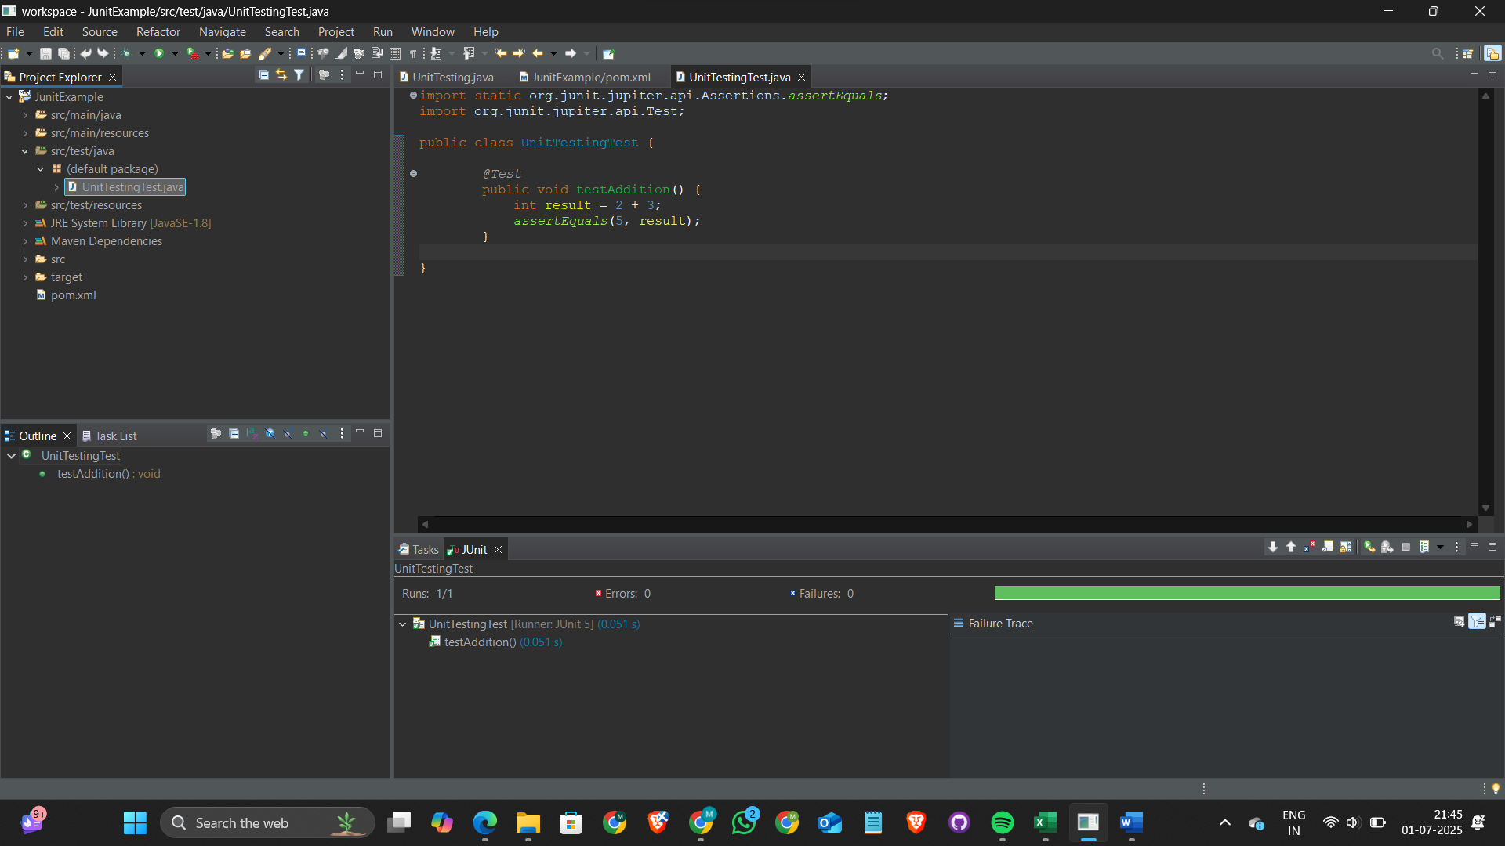

**Exercise 3: Assertions in Junit**

**Implementation:**

**CODE:**

**pom.xml:**

<project xmlns="http://maven.apache.org/POM/4.0.0" xmlns:xsi="http://www.w3.org/2001/XMLSchema-instance" xsi:schemaLocation="http://maven.apache.org/POM/4.0.0 https://maven.apache.org/xsd/maven-4.0.0.xsd">

<modelVersion>4.0.0</modelVersion>

<groupId>myProject</groupId>

<artifactId>JunitExample</artifactId>

<version>0.0.1-SNAPSHOT</version>

<dependencies>

<!-- junit 5, unit test -->

<dependency>

<groupId>org.junit.jupiter</groupId>

<artifactId>junit-jupiter-engine</artifactId>

<version>5.10.2</version>

<scope>test</scope>

</dependency>

</dependencies>

</project>

**UnitTestingTest.java:**

import static org.junit.jupiter.api.Assertions.*;

import org.junit.jupiter.api.Test;

public class UnitTestingTest {

@Test

public void testAssertions() {

assertEquals(5, 2 + 3);

assertTrue(5 > 3);

assertFalse(5 < 3);

assertNull(null);

assertNotNull(new Object());

}

@Test

public void testArrayEquals() {

int[] expected = {1, 2, 3};

int[] actual = {1, 2, 3};

assertArrayEquals(expected, actual, "Arrays should be equal");

}

@Test

public void testAssertAll() {

int value = 5;

assertAll(

"Multiple checks",

() -> assertTrue(value > 0),

() -> assertEquals(5, value),

() -> assertNotEquals(0, value)

);

}

@Test

public void testAssertSame() {

String a = "hello";

String b = a;

assertSame(a, b, "Both references should be the same");

}

}

**OUTPUT:**

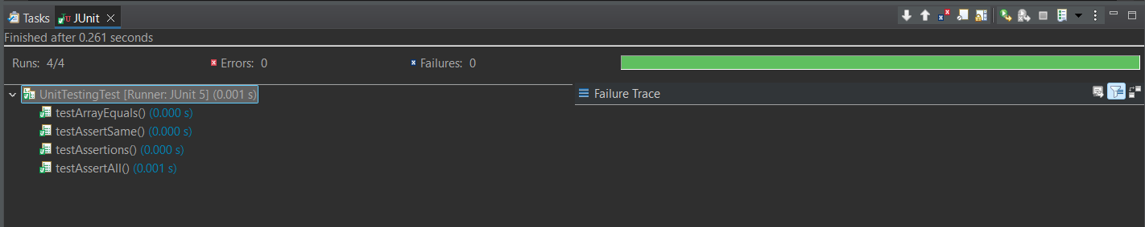

**Exercise 4: Arrange, Act & Assert Pattern, Test Fixtures, Setup and**

**Teardown Methods in Junit**

**Implementation:**

**CODE:**

**pom.xml:**

<project xmlns="http://maven.apache.org/POM/4.0.0" xmlns:xsi="http://www.w3.org/2001/XMLSchema-instance" xsi:schemaLocation="http://maven.apache.org/POM/4.0.0 https://maven.apache.org/xsd/maven-4.0.0.xsd">

<modelVersion>4.0.0</modelVersion>

<groupId>myProject</groupId>

<artifactId>JunitExample</artifactId>

<version>0.0.1-SNAPSHOT</version>

<dependencies>

<!-- junit 5, unit test -->

<dependency>

<groupId>org.junit.jupiter</groupId>

<artifactId>junit-jupiter-engine</artifactId>

<version>5.10.2</version>

<scope>test</scope>

</dependency>

</dependencies>

</project>

**Calculator.java:**

public class Calculator {

public int add(int a, int b) {

return a + b;

}

public int subtract(int a, int b) {

return a - b;

}

}

**CalculatorTest.java:**

import org.junit.jupiter.api.BeforeEach;

import org.junit.jupiter.api.AfterEach;

import org.junit.jupiter.api.Test;

import static org.junit.jupiter.api.Assertions.*;

public class CalculatorTest {

private Calculator calculator;

@BeforeEach

void setUp() {

calculator = new Calculator();

System.out.println("Setup complete");

}

@AfterEach

void tearDown() {

calculator = null;

System.out.println("Teardown complete");

}

@Test

void testAddition() {

int a = 2;

int b = 3;

int result = calculator.add(a, b);

assertEquals(5, result);

}

@Test

void testSubtraction() {

int a = 5;

int b = 2;

int result = calculator.subtract(a, b);

assertEquals(3, result);

}

}

**OUTPUT:**

